Scarecrow Competition
Create a scarecrow based on a book character. Display it outside your home, any time from June 30th, then bring it along to the Village Bash on July 14th. We will be displaying scarecrows and judging them during the event.
Prizes for 1st, 2nd and 3rd place.
Please let us know if you plan to enter by emailing emma.baughan@outlook.com, so that we can send you the guidelines.
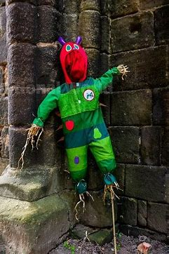
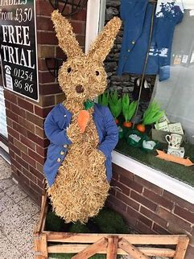
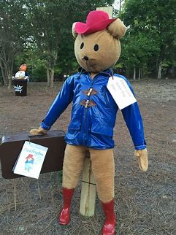
Good luck!

