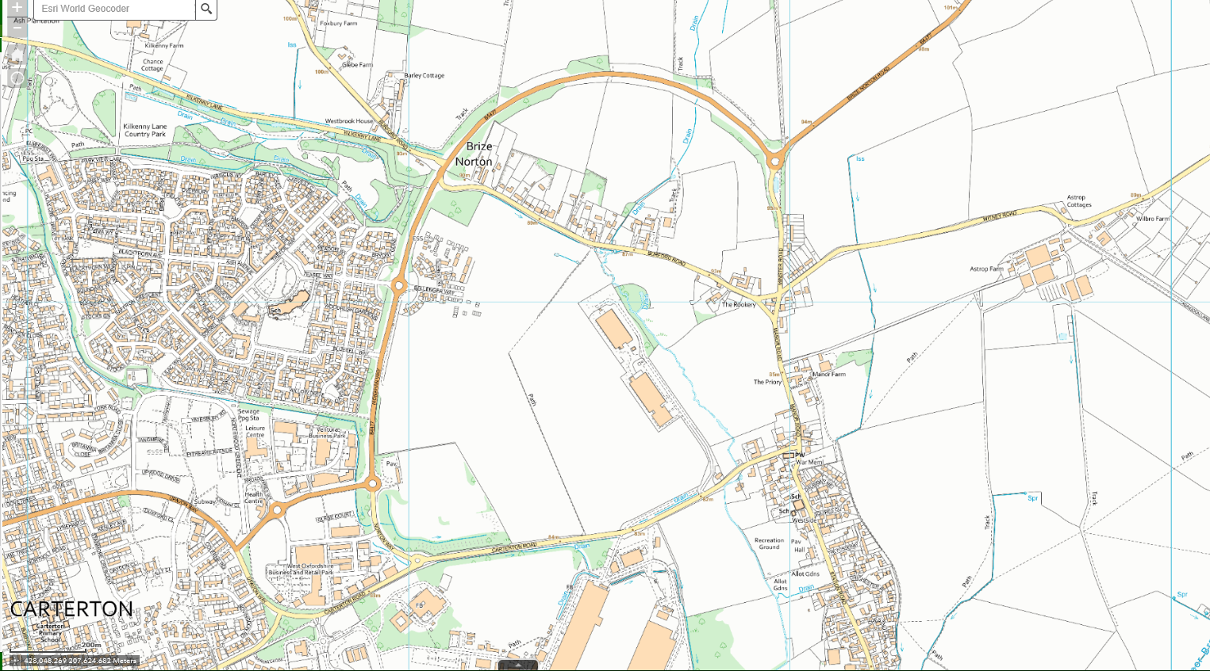

DIVERSION ROUTE

ROAD CLOSURE

BRIZE NORTON – MINSTER ROAD – ROAD CLOSURE – 18-22 MAY 2020